TASK 01:

#include <stdio.h>

int main() {

    int x;

    int evenCount = 0, oddCount = 0;

    char ch = 'y';

    do {

        printf("Enter a number: ");

        scanf("%d", &x);

        if (x & 1) {

            printf("%d is Odd.\n", x);

            oddCount++;

        } else {

            printf("%d is Even.\n", x);

            evenCount++;

        }

        printf("Do you want to continue? (y for yes / n for no): ");

        scanf(" %c", &ch);

    } while (ch == 'y' || ch == 'Y');

    printf("\nTotal Even numbers entered: %d\n", evenCount);

    printf("Total Odd numbers entered: %d\n", oddCount);

    return 0;

}

OUTPUT:

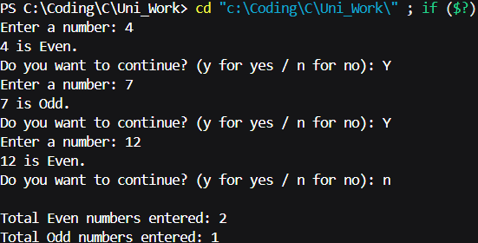

TASK 02:

#include <stdio.h>

int main() {

    int x;

    int sum = 0,count = 0;

    printf("Enter a number: ");

    scanf("%d", &x);

    printf("Prime numbers till %d are:\n", x);

    for(int i = 2; i <= x ; i++){

        int prime = 1;

        for(int j =2; j<=i-1;j++){

            if(i % j == 0){

                prime = 0;

                break;

            }

        }

        if(prime){

            printf("%d ", i);

            count++;

            sum+=i;

        }

    }

    printf("\nTotal prime numbers till %d: %d\n",x, count);

    printf("Sum of total prime numbers till %d: %d\n",x, sum);

    return 0;

}

OUTPUT:

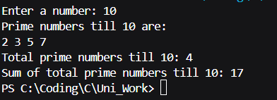

TASK 03:

#include <stdio.h>

int main() {

    int x,i=2;

    int next,first = 0 , second = 1,sum=0;

    printf("Enter a number: ");

    scanf("%d", &x);

    printf("%d ", first);

    printf("%d ", second);

    while(i<x){

        next = first + second;

        printf("%d ", next);

        sum+=next;

        first = second;

        second = next;

        i ++;

    }

    printf("\nSum of series till %dth term: %d\n",x, sum);

    return 0;

OUTPUT:

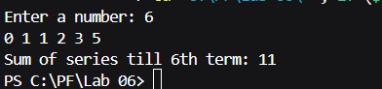

TASK 04:

#include <stdio.h>

int main() {

    char x;

    int v_count = 0, c_count = 0;

    char ch = 'y';

    do {

        printf("Enter a alphabet: ");

        scanf(" %c", &x);

        if (x == 'a' || x == 'e' || x == 'i' || x == 'o' || x == 'u'||x == 'A' || x == 'E' || x == 'I' || x == 'O' || x == 'U') {

            v_count++;

        } else {

            c_count++;

        }

        printf("Do you want to continue? (y for yes / n for no): ");

        scanf(" %c", &ch);

    } while (ch == 'y' || ch == 'Y');

    printf("\nTotal numbers of vowels entered: %d\n", v_count);

    printf("Total numbers of consonants entered: %d\n", c_count);

    return 0;

}

OUTPUT

